 **Packet Tracer Project**

**What to hand in?**

* **Send a packet tracer (.pkt) file and word file(.doc) which contains questions and answers of ASSIGNMENT section. Zip these two files as a document** andnamed as ***studentNo1_ studentNo2_ studentNo3_Project***.
* Late submissions are not allowed.
* Team working is allowed. A team can consist of at most 3 member. Indicate all project members number-name in the .doc file. Each member of team should upload project to Classroom.
* Copy homework will be evaluated as 0.
* Use Google Classroom for your questions. Do not send private messages.

**Create a Network Using Cisco Packet Tracer**

In this lab, you will learn how to create LAN (Local Area Network) using cisco packet tracer, making basic configurations of network devices and providing communication between two devices in simulation environment.

**Installation and Running Cisco Packet Tracer**

Before installation, you have to register. Do not forget mail address and password. You have to login before start the program. Go to <https://www.netacad.com/courses/packet-tracer>. Scroll down to page and click on “Enroll to download Packet Tracer” button. In opening page, there is a free packet tracer course. Click on “Sign up today” button and select “English”. In opening form, fill the necessary information and click on “submit” button. Activation mail will be sent to you. Activate your account, enter other information, click “Register” button. After registration is completed, sign in with your e mail address-password. Fill necessary information in the form, click on ” Create Account” button. In opening page go to “Resources Tab” and select “Download Packet Tracer”. Select suitable version for your computer.

After download process, installation process is pretty simple. You can easily install by clicking “next” button and following the instructions.

**Example: Create a LAN**

Connect three end devices (PC s) using a switch as in the figure given below:

1. Make physical (connect devices, cables…etc.) and logical (make ip configurations) connections. Configure end devices ip address as 192.168.1.1. , 192.168.1.2 and 192.168.1.3 respectively.
2. Send a ping from PC 0 to PC 2 using command prompt. Show reply messages.
3. Send a PDU (Protocol Data Unit) from PC 0 TO PC 2 in simulation mode. Select ICMP filter and show all events in event list.

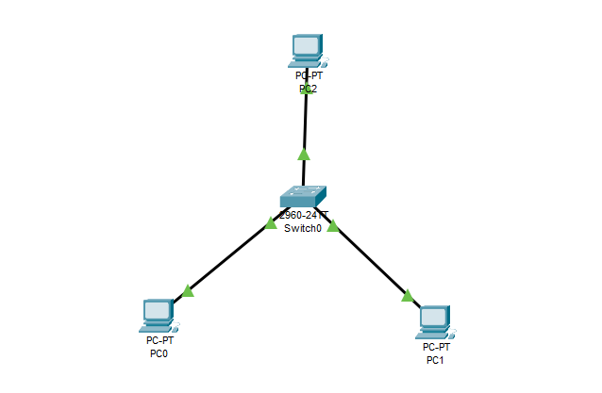

**Solution: Create a LAN**

1. **Make physical and logical connections. Configure end devices ip address as 192.168.1.1. , 192.168.1.2 and 192.168.1.3 respectively.**

Connections, end devices and network devices can be accessed from bottom left corner:

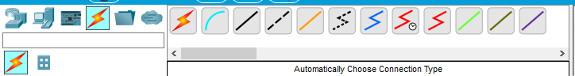

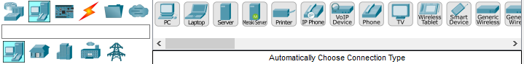

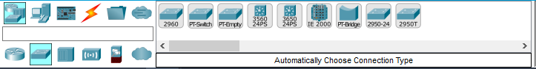

Select red square defined components to create the network. For configuring ip address, click on PC 0, select “desktop” tab, click on “IP configuration”. Enter IP address. Apply these steps for each end device.

* Ip address consists of 4 parts(octets). First three octets(8 bits) of IP address identify the network and the remaining 8 bits indicate the host within the network. That’s why first three octets of IP address should be same for devices that exist in the same network.

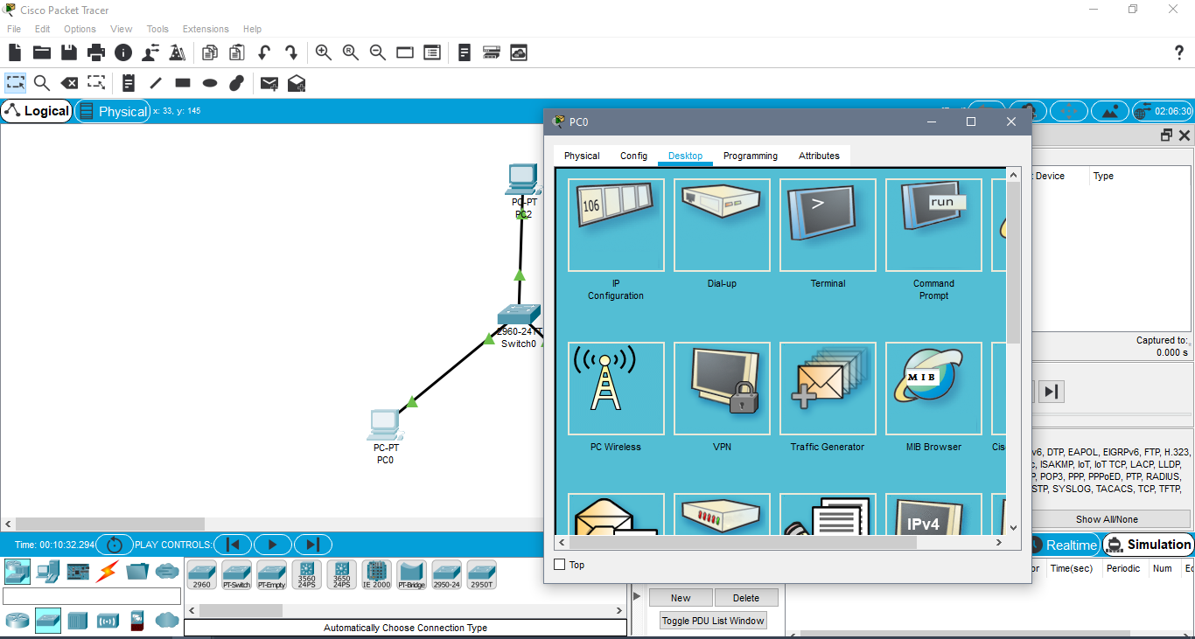

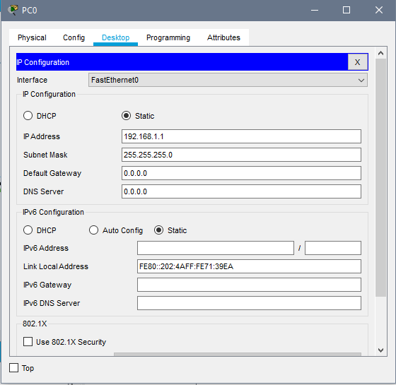

After making physical connections, all connection points should turn into green color. You may press “forward” button to quicken the process.

1. **Send a ping from PC 0 to PC 2 using command prompt. Show reply messages.**

Click on PC 0, select “desktop” tab, click on “Command Prompt”. Enter: ping <ip address of PC2>



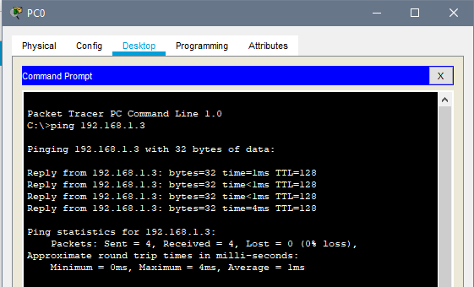

Reply messages can be seen on screenshot above.

1. **Send a PDU (Protocol Data Unit) from PC 0 TO PC 2 in simulation mode. Select ICMP filter and show all events in event list.**

Select “Simulation” button from bottom right corner. In opening simulation panel, click on “Edit Filters” button and check only ICMP for capturing PDU events.

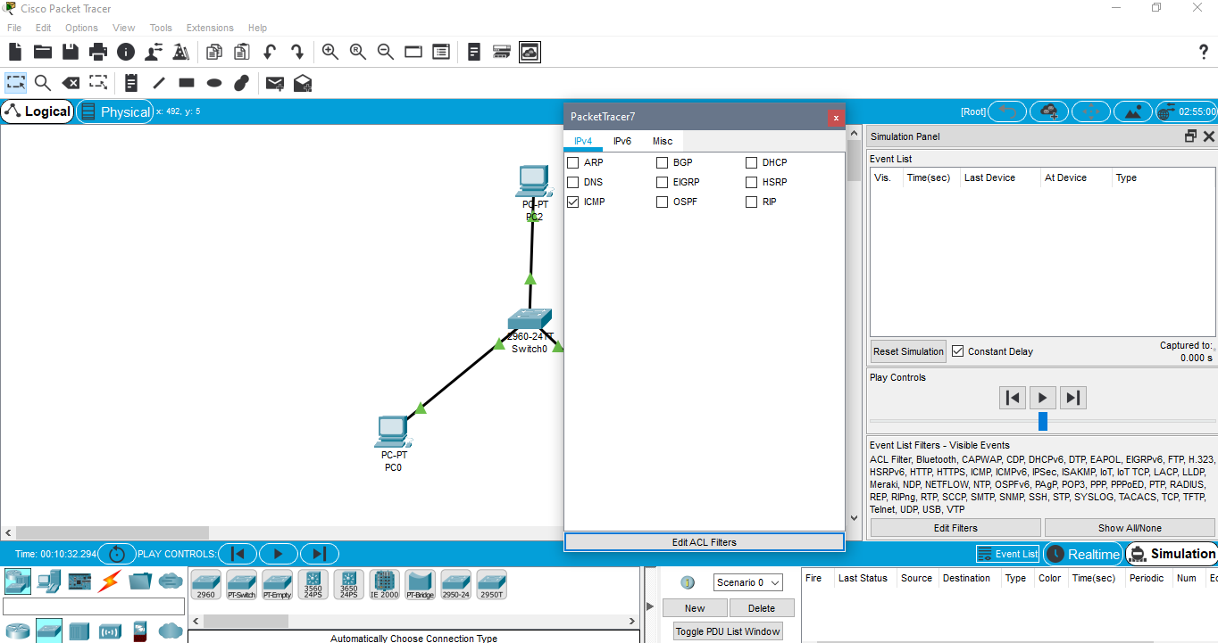

**7**

**6**

**5**

**4**

**3**

**2**

**1**

Add Simple PDU

Click envelope for “Add simple PDU” then click source device and destination device respectively. Then click on “forward” button couple of times until message goes to destination and turn back to source device. Final event list is given below:

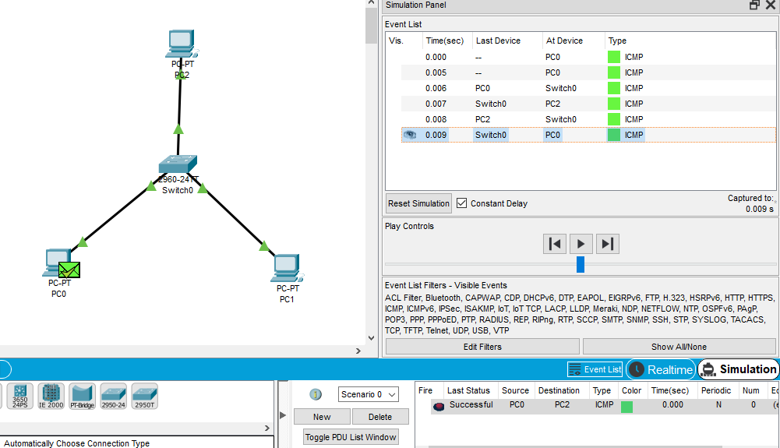

**ASSIGNMENT**

Create a network in the figure given below and perform **a**, **b**, **c,** **d** processes using Cisco Packet Tracer. In the figure, two different networks (192.168.1.0 and 192.168.2.0) are connected via router. Send **.pkt (packet tracer)file** and **.doc file** in zipped format.

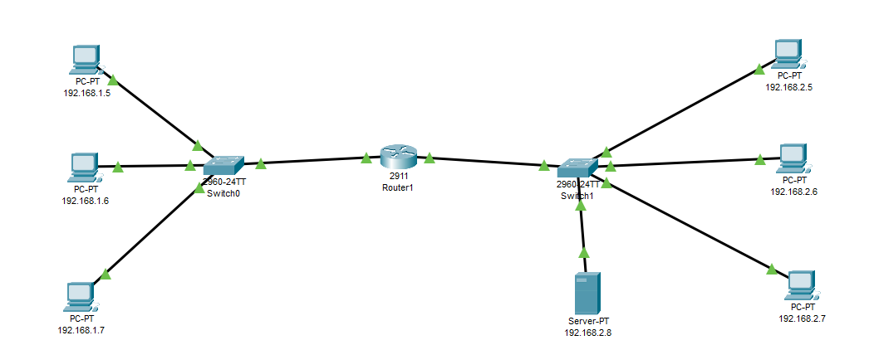

1. Make physical (connect devices, cables…etc.) and logical (make ip configurations) connections. Configure 7 end devices ip address according to last 2 digit of each team member’s student numbers.

Ex:(see figure below for team of 3 member whose last 2 digit of students numbers are “05”-“06”-“07”)

**As an answer of (a),** **Take a screenshot of network (as in figure), paste into word file and explain briefly.**

**b)** Send a ping using command prompt from one PC to another PC which are placed in different networks. Show reply messages. Indicate source ip address and destination ip address.

**As an answer of (b),** **Take a screenshot of command prompt messages paste into word file and explain briefly.**

**c)** Send a PDU (Protocol Data Unit) from one PC to another PC which are placed in different networks in simulation mode. Select ICMP filter and show all events in event list. Indicate source ip address and destination ip address.

**As an answer of (c),**  **Take a screenshot of simulation panel event list. Paste into word file and explain briefly.**

**d)** Configure web server so that 2 PCs (one from same network with Server, other from different network) can connect to web server using web browser (via desktop tab of PC ). What information do you see in browser? Indicate ip address of the 2 PC and web server.

**As an answer of (d), Take a screenshot of each PC s web browser(in our case: there are 2 PC, 2 screenshot will be enough). Paste into word file and explain briefly.**

**e)** Modify the website which is hosted in Web Server so that student number, name and surname of each team member should be seen like in the figure below. Indicate ip address of the 2 PC and web server.

**As an answer of (e), Take a screenshot of each PC s web browser(in our case: there are 2 PC, 2 screenshot will be enough). Paste into word file and explain briefly.**

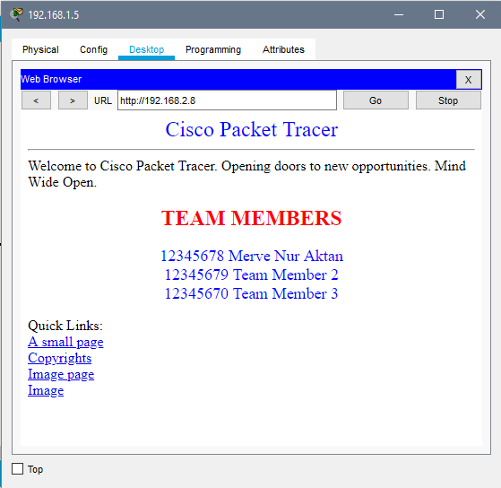

**Save packet tracer file (.pkt) after completed all steps.**